University of Engineering and Technology, Lahore
Name: Maria Abbas
Reg No: 2026(S) CYS_61
Department: Computer Engineering
Degree: Cyber security
Section: B
Assignment: PF Lab week 1
Date: 16 Feb 2026
CLO1

Lab Tasks:
Input, Output data types, conditional statement, operators
Task 1:
This programme takes input and gives sum of integers.

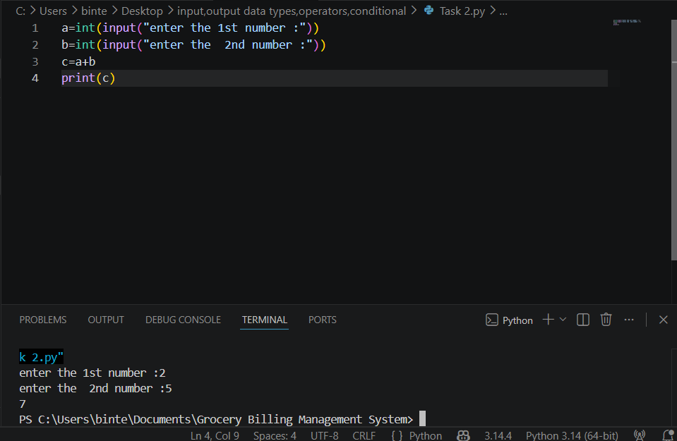

Task 2:
This programme prints input and gives us output.
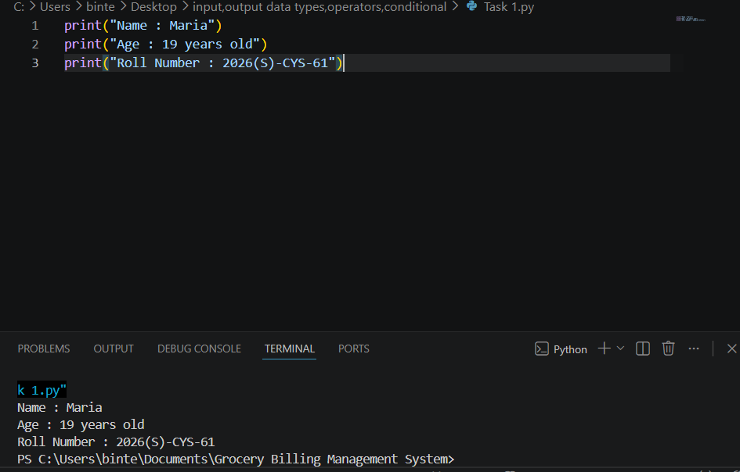
Task 3:
This programme takes a byte value from the user and converts it into Megabytes and Gigabytes.
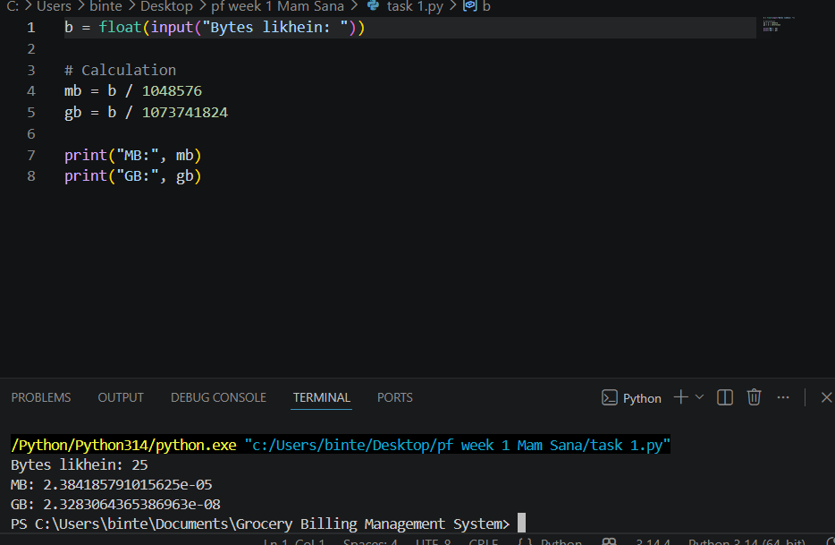
Task 4:
This programme calculates the total university admission aggregate based on weighted percentages of ECAT, Inter, and Matric. It highlights the arithmetic operators to mathematical formula.
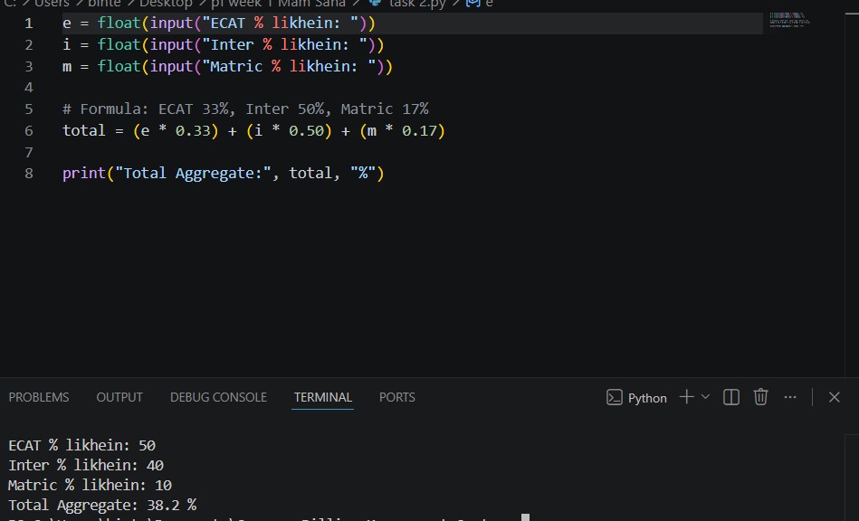
Task 5:
This programme calculates the geometric distance between two points and determines the specific quadrant of the first point.
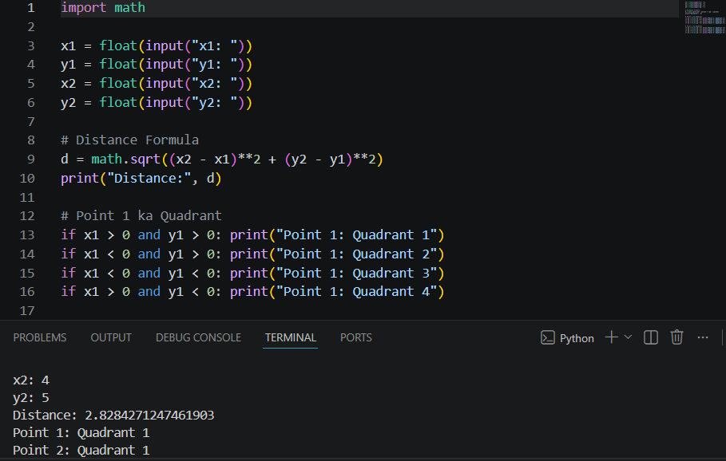
Task 6:
This programme solves a quadratic equation by calculating its discriminant to find the exact nature of its roots. It focuses on a conditional statement.
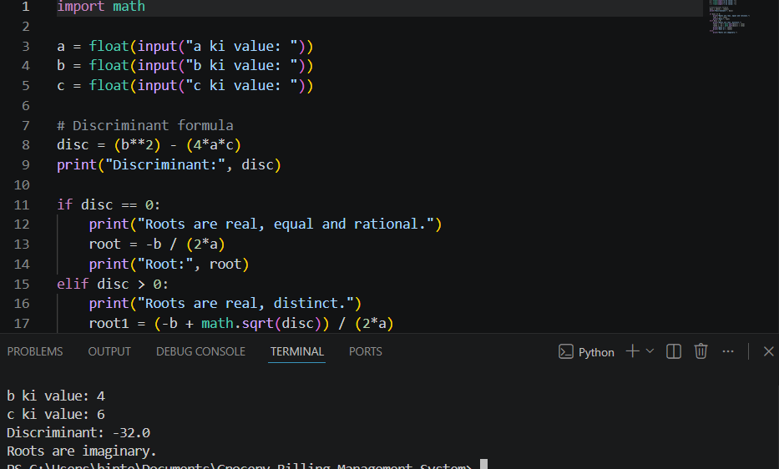
Task 7:
This programme converts a user binary number string into its standard decimal integer equivalent.
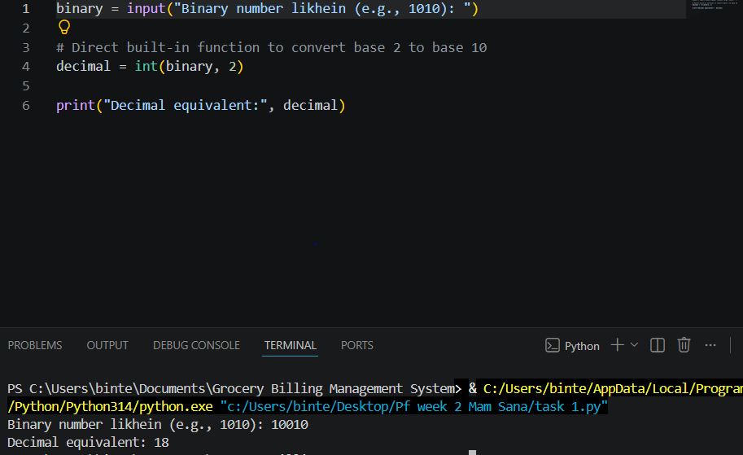
Task 8:
This programme calculates the grades of students.
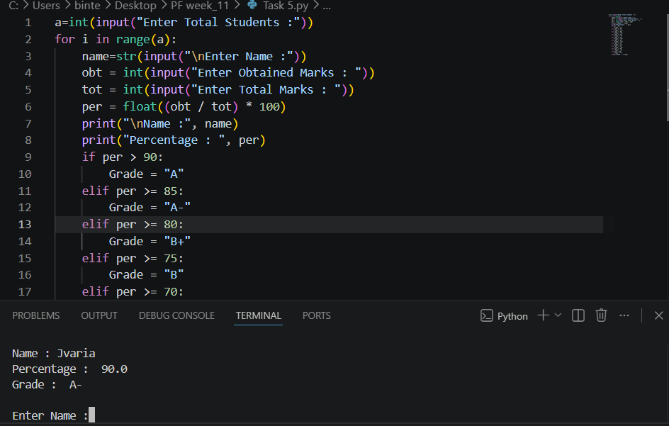
Task 9:
This programme makes sum of two numbers.
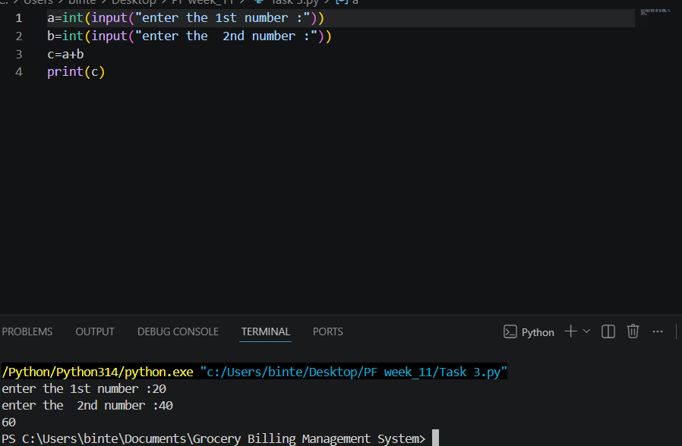
Task 10:
This programme highlights how textual data is initialized and printed directly to screen without complexity.
